From Mosaic to Figure
How a student’s LEGO tile mosaic becomes a 3D figure — design analysis, Version 1.1, 2026-07-26

1. What changed since Version 1.0
Version 1.0 put the work in Sangala Studio: import the mosaic, trace each mass with the Pen, extrude it. That plan is withdrawn. Three things overturned it — the tracing surface it depended on does not exist for most mosaic files, extrusion of a traced outline proved to carry the mosaic’s viewpoint along with its masses, and Chapter 5’s own photographs show students already doing something simpler and better. The relief now belongs in Sangala Mosaic, built from the tiles themselves, and Sangala Studio keeps the figure.

2. The evidence that settled it
Chapter 5 contains photographs that answer the question directly. In Billy Ganbold’s elephant the flat tile mosaic lies in the foreground and the built figure stands behind it — the same head-on view in both, with each mass given its own depth: the ears stepped outward, the trunk and tusks stepped forward, the eye a dark tile in the mosaic and a recessed dark brick in the figure. The crane does the same in profile. Neither student changed the pose. They kept the view their mosaic gave them and worked in depth, which is precisely the relief rung.
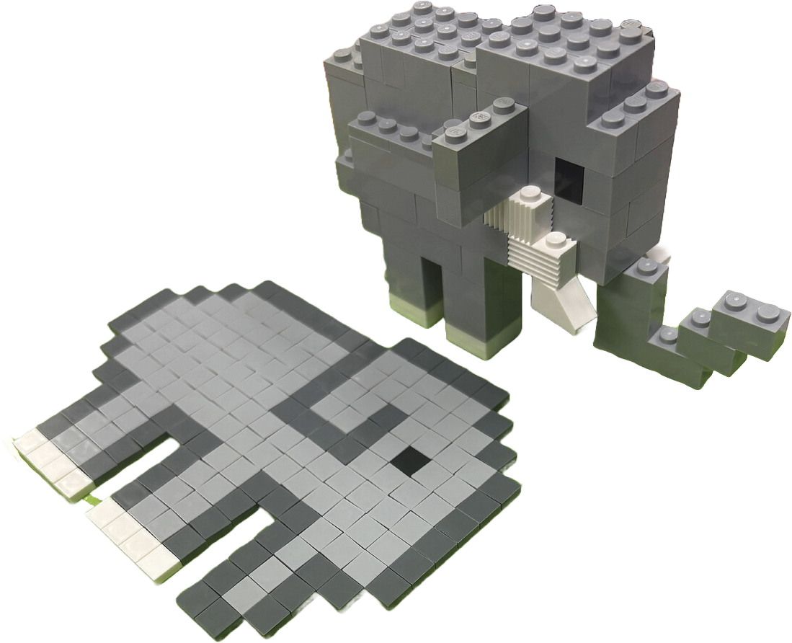
Figure 1. Billy Ganbold’s elephant: the flat mosaic and the built figure, same view,
depth added per mass. Photograph from Chapter 5.
The counter-case matters too. The water buffalo’s mosaic is head-on and Moses Kumenya’s figure was built in three-quarter profile, so pose is a variable the student sets, not something the mosaic dictates. A relief cannot re-pose; that is the boundary between the two applications.

3. The three tools
Group — build it, first. Selecting tiles and treating them as one named mass is the operation the whole design rests on, and the other two have nothing to attach to without it. The feature is the selection gesture. Painting cell by cell is the gesture already rejected as hard to control, and selecting by color fails on the measured data: in Buffalo.mosaic a single same-color region runs to 102 tiles spanning face, body and legs. An anchored drag — press on a tile, drag a box, take that tile’s connected region clipped to the box — isolates a mass in one gesture without needing a boundary that the tiles do not contain. One caveat on the wording: the request was color and shading, and a group that re-asserts one flat color erases shading within the mass, so a group should hold an optional color applied on command rather than restamped.
Stepped Elevate — build it after Group, with three changes. Courses belong to the mass, not the tile: per-tile height rebuilds the pixel-by-pixel trap Group exists to escape. Count in plates of 3.2 mm with a brick at three plates, which the Studio code already fixes. And the relief carries no brick bill of materials — a stepped column has no unique decomposition into real bricks — so show only the two figures both real builds were conceived in: each mass’s footprint in studs and its height in courses.
Brick Selector — defer it. The proposal was to derive the palette from what previous classes actually used, and that corpus is two documented figures whose parts barely overlap: the buffalo’s workhorses are 1x2 bricks and short plates, the owl’s are four 1x8 bricks plus twenty-six pieces its authors do not name. Four builds encode four parts bins rather than a design vocabulary. The one durable pattern is that a 45-degree slope appears in four of five figures, which argues for a per-mass option to cap a mass with a slope, not a parts palette. Fall 2026 with ten teams, each writing a build note, is the study that would make a curated list defensible.
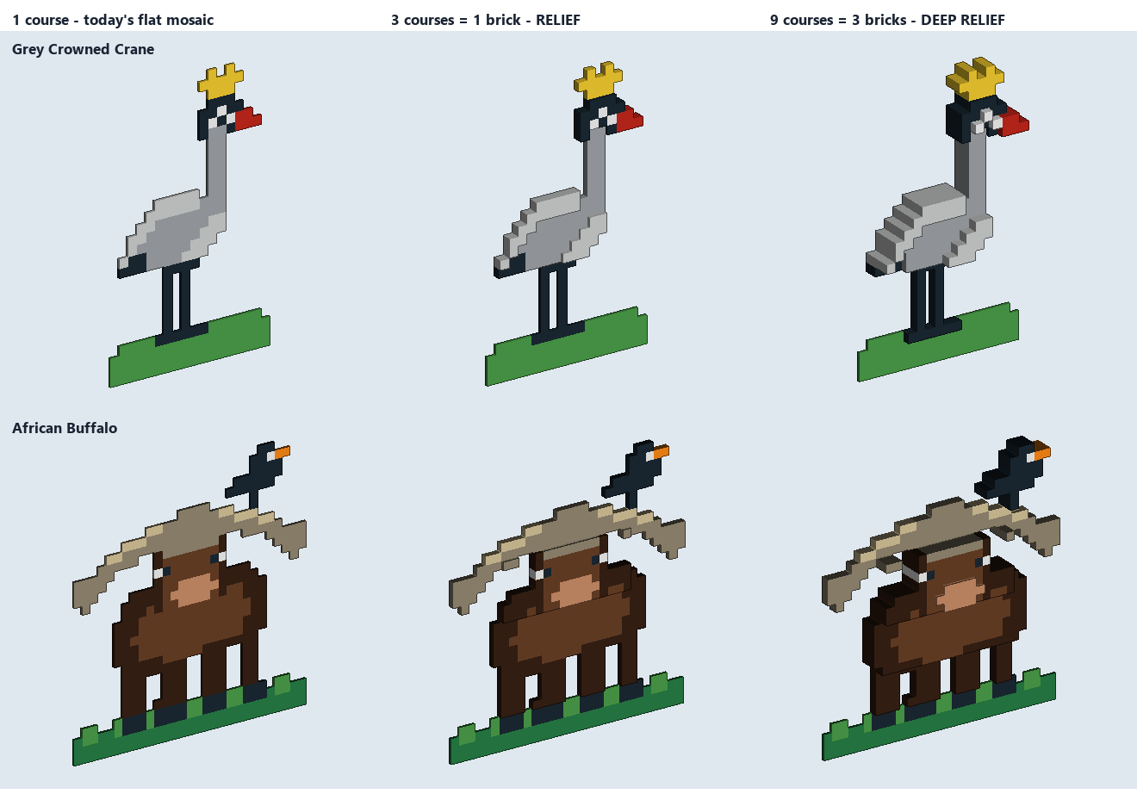
Figure 2. What the two tools produce: the crane and the buffalo at one course
(today’s flat mosaic), three courses (one brick), and nine (three bricks).
Figure 2 is the call the evidence cannot make for anyone else. The crane gains real form — the wing terraces clear of the body, the crown lifts off the head. The buffalo gains less, because a head-on silhouette is already doing much of the work, though the horn sweep separates from the face and the muzzle comes forward. Whether that is worth two features is a judgment about the course, not about the code.

4. Architecture
The relief rung moves into Sangala Mosaic, which becomes 2.5D behind a 2D/3D toggle mirroring the one in Sangala Studio. The figure rung stays in Studio. The charter line worth writing down is not dimensionality but this: Mosaic may own a height field; Mosaic may never own a mesh. No boolean geometry, no manifold repair, no STL. When a Mosaic feature needs one of those, it belonged in Studio.
The handoff costs nothing on the Studio side, because the path already exists and was verified line by line. Mosaic writes an ordinary SVG — one closed polygon per mass, millimeter coordinates, carrying data-z and data-z0. Studio’s Open routes any .svg to loadSVG, which adopts the file’s own element so unrecognized attributes survive; a file with no red strokes has every shape treated as a cut; and any polygon with a positive Depth is a 3D solid, so slopes, Mirror, booleans and STL all apply on arrival. Scale needs no conversion at all: Mosaic’s tile pitch and Studio’s stud pitch are both 8 mm.
What this deletes from the Version 1.0 plan: the .mosaic importer, never to be written; the composited tracing surface, which cannot exist; Pen tracing as the route to masses, though the Pen keeps its real job of turning a photo into a cut design; and the stud-lattice retrofit, since a relief built on tiles arrives on the lattice already.
Studio keeps what a height field structurally cannot express, and Moses’s buffalo is the argument: the body stands clear of the plate on four columns, the head is cantilevered forward over open air, and the eye sits on a vertical face. No elevation map describes an undercut, a cantilever, or a side-mounted part.

5. What ships first
Group alone, in Mosaic — no new view, no format change beyond two fields, no heights. Store mass membership outside the built grid from the first line, because build() replaces that object wholesale.
The test: open Projects\Buffalo.mosaic and try to isolate the face from the body. Today the brown region is one 102-tile blob. If one press-and-drag gets the face, the data model is right and Elevate is safe to build on it. Then nudge the Colors slider and confirm the mass survives.

6. Corrections to Version 1.0
The tracing surface does not exist. Four of the six .mosaic files on disk store an empty layers array, carrying no source photo — including both Crane.mosaic and Buffalo.mosaic. Only Sample.mosaic and Mosaic project.mosaic embed one. Version 1.0 described tracing over the mosaic with the photo showing through as though it were always available.
The two claimed defects are not defects. yzPrism takes no holes parameter and its only callers pass hole-free brick-slope profiles; holed shapes already route through the through-hole path. Nothing in the shipping application drops interior holes. These are pitfalls for a feature that does not exist, and Version 1.0 reported them as faults found in the code.
The depth thresholds are withdrawn. The figures of 14, 22 and 36 mm were untethered from the size of the figure. Express the relief in courses instead — three courses, one brick, for a relief and nine for a deep relief — and note that the real quantity is the ratio of step height to mass width.
The free-versus-snap verdict is moot. It tested naive rounding of a traced outline. With the relief built on tiles, the tile pitch already is the stud pitch, so a mass footprint is a whole number of cells and there is no continuous value to destroy.
One hazard is narrower than stated. build() returns immediately when a project has no photo layer, so for the four photo-less files the Colors and Contrast sliders do nothing at all. The risk of a slider nudge discarding hand work applies only to photo-backed mosaics.
Attribution, which Version 1.0 left vague. The water buffalo figure and its photograph are Moses Kumenya’s, the owl is Siisa Precious and Kuloba Emma’s, and the elephant in Figure 1 is Billy Ganbold’s.

7. What is verified, and what is not
Every code reference and every count in this version was checked directly against the files: the connected-region counts (191 tiles in 101 regions for the default crane; 480 tiles in 31 regions for the buffalo, the largest 102), the empty layers arrays, the early return in build(), the SVG import path, and the 8 mm coincidence between tile and stud. Figure 2 is a rendering produced outside the applications to show what the tools would make; it is not a screenshot of Mosaic, which cannot yet do this. Nothing here has been tested with students, and nothing has been built in either application.

8. Open decisions
Whether Figure 2 justifies the work. The crane gains substantially, the buffalo less. That is a judgment about the course.
Where the relief sits in the book. The close of Chapter 4, or the opening of Chapter 5, which is otherwise the by-hand chapter and currently names neither application.
Mosaic’s defaults. A photo needs more resolution and fewer colors than the current 32 by 32 at nine colors. Changing a default changes how every saved project rebuilds, so this may belong in the guide instead.
Whether the artifact is a picture or a plan. The specification says not a literal one-for-one plan, and the Uganda team called the AI image their building plan. The stud-and-course readout exists only if the students’ reading wins.

